Azure B2C SSO (DEV) – BUILD BOOK

Version: 1.0

Date Issued: 2 March 2022

# 

Revision Record

|  |  |  |  |
| --- | --- | --- | --- |
| **Version** | **Author** | **Description** | **Date Issued** |
| 1 | Frederick Pearson | Initial draft (MD) | December 21, 2021 |
|  |  |  |  |
|  |  |  |  |
|  |  |  |  |
|  |  |  |  |
|  |  |  |  |

Table - Revision record, document

Table of Contents

1. Azure B2C Tenant for Development Environment 3

Pre-requisites 3

Steps 3

# Azure B2C Tenant for Development Environment

## Pre-requisites

Before your applications can interact {ENVIRONMENT}’s Azure Active Directory B2C (Azure AD B2C), they must be registered in the {ENVIRONMENT}’s Azure subscription.

f

* A Global Administrator Azure AD account OR.
* An Azure AD account assigned at least the Contributor role within the {ENVIRONMENT} subscription or a resource group within the subscription is required.

## Steps

* Sign in to the Azure portal.
* Switch to the directory that contains the primary subscription (or a Dev subscription preferably). The directory should be on the domain that is connected to the on premise active directory so that B2C configurators leverage their federated accounts instead of cloud only domain accounts (optional-this can be done using your .onmicrosoft.com identity).

Once in signed into the Azure subscription as Global Administrator or Subscription Owner, select “Create Resource”

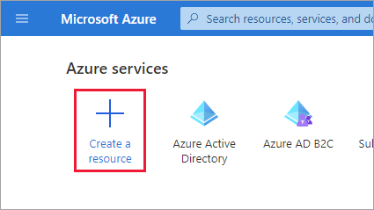

Search for Azure Active Directory B2C, press Enter and select “Create”

In the Create blade, click on “Create a new Azure AD B2C Tenant”

In the following step, enter {ENVIRONMENT}b2cdev for both the organization name and initial domain name (which will be the subdomain) and fill in the country, subscription, resource group and resource group region

Click on Review and Create and if Validation has passed click on Create.

Once created, add Frederick Pearson and {OTHERADMIN} as Global Administrators to the Development B2C environment to configure the TEST GCCF relying party.

To do so, click on your profile in the top right, and select switch directory, and switch to the new Azure B2C directory just created

Once you are in the new directory search for Azure AD B2C

Select Users from the Menu Blade

Select New User

Select “Invite User”, enter the name “Frederick Pearson”, email [Frederick.pearson@{yourdeptnumber}.onmicrosoft.com](mailto:Frederick.pearson@%7byourdeptnumber%7d.onmicrosoft.com) AND the [frederick.pearson@yourdeptdomain.gc.ca](mailto:frederick.pearson@yourdeptdomain.gc.ca) federated account (will be used until SSO), click on Role “user” and select “Global Administrator” (*note this only applies Global Admin rights to the newly created Dev B2C tenant)* and press select. Once completed, press “Invite”. Repeat the same step for Serge Lebrun (or other user who will be configuring the initial development environment for GCCF (GCKEY) integration in B2C.

